EXPERIMENT-2
1. # Customer Ages
age <- c(25, 30, 35, 28, 40)

# Histogram
hist(age,
main = "Distribution of Customer Ages",
xlab = "Age",
ylab = "Frequency",
col = "lightgreen",
border = "black")

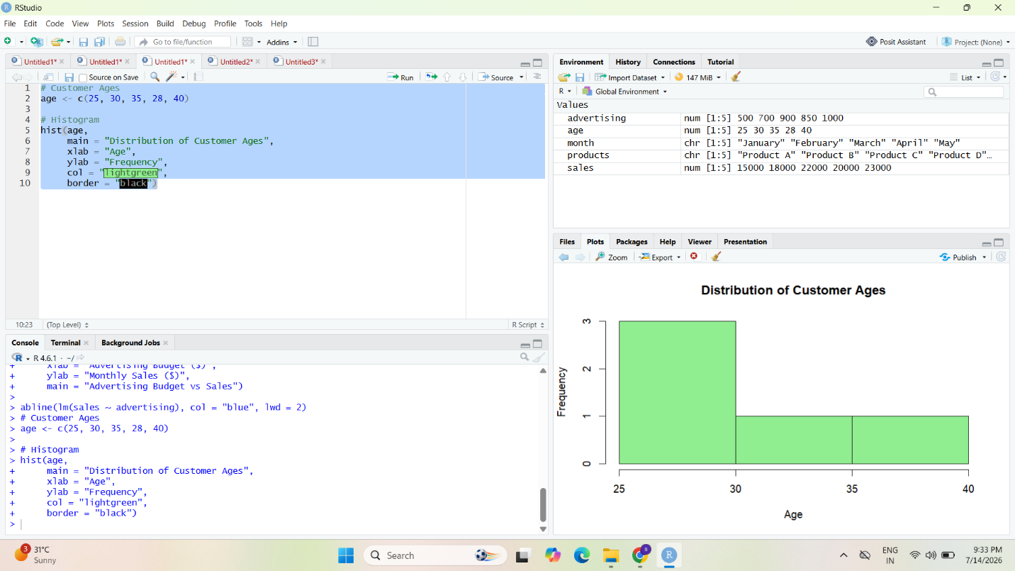

2. # Customer Satisfaction Scores
score <- c(4, 5, 3, 4, 5)

# Frequency Table
freq <- table(score)

# Pie Chart
pie(freq,
labels = paste(names(freq), "-", freq),
col = rainbow(length(freq)),
main = "Customer Satisfaction Scores")

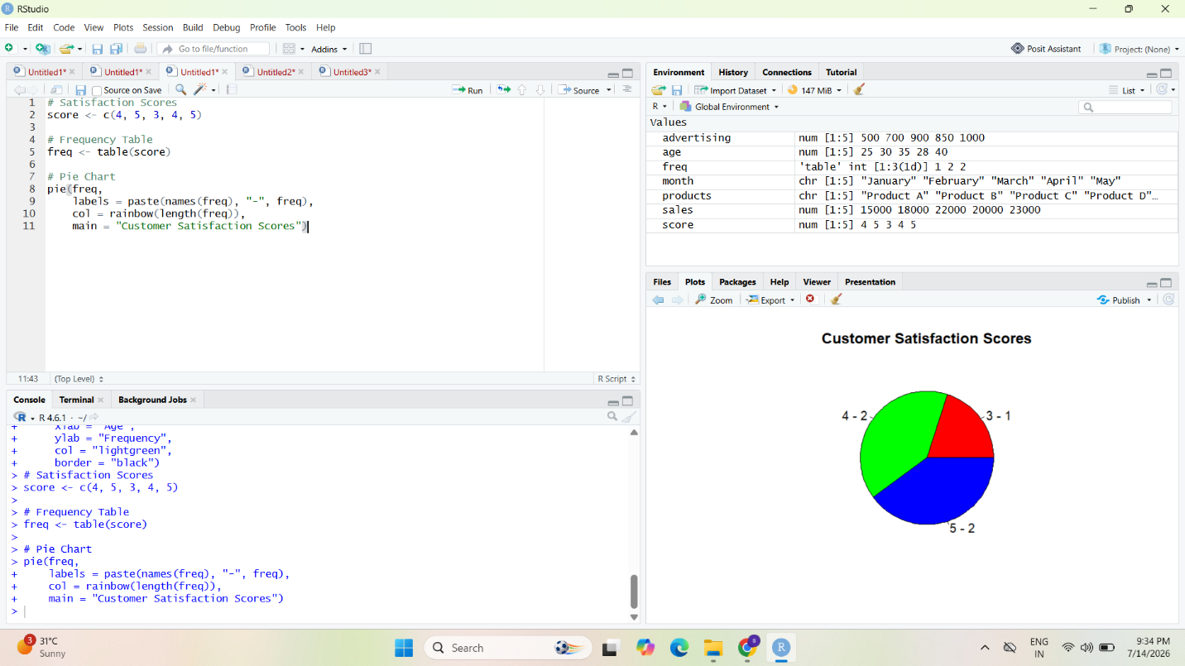

3. # Data
age_group <- c("20-29", "30-39", "30-39", "20-29", "40-49")
score <- c(4, 5, 3, 4, 5)

# Create Frequency Table
data <- table(age_group, score)

# Stacked Bar Chart
barplot(data,
col = rainbow(ncol(data)),
legend = colnames(data),
xlab = "Age Group",
ylab = "Number of Customers",
main = "Customer Satisfaction by Age Group")

